

PRE BOARD EXAMINATION 2019 MARCH
Bachelor Level/First Year/I Semester Full Marks: 60
Computer Science and Information Technology Pass Marks: 24
Digital Logic Time: 3 Hours
Examination Date: 27th, Mar, 2019

Candidates are required to give their answers in their own words as for as practicable.
The figures in the margin indicate full marks.
SET B

Group A (Long Answer Question Section)
Attempt any TWO questions. (2x10=20)

- Implement the following function F=Ʃ(0,1,2,4,7) using
a) Decoder
b) Multiplexer
c) PLA

- Differentiate between synchronous and asynchronous sequential circuit. Design a counter as shown in the state diagram below

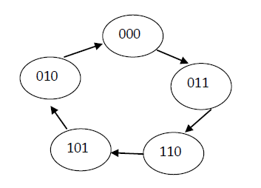

- Explain working principle of binary up/down counter with necessary
diagram.

Group B
(Short Answer Question Section)
Attempt any EIGHT questions. (8x5 = 40)

- Use K-map to simplify the given function in POS. Implement the simplified function using 2-input NOR gate only.
F = ∏M(0,1,2,9,10,11,14)
With don’t care condition
D = ∏M(7,8,12)
- Discuss race condition in J-K Flip flop and methods to overcome it.
- Convert (2AC5)16 to decimal, octal and binary.
- Design a circuit that produces the square of three bit number using ROM?
- Design a 2-bit magnitude comparator.
- Design a BCD to excess -3 code converter.
- Perform the arithmetic operations (+42) + (-13) and (-42)-13 in binary using the signed 2’s complement representation for negative numbers.
- Show that a positive logic NAND gate is a negative logic NOR gate and vice versa.
- Write short notes on (Any two)
  - CMOS
  - Don’t care condition
  - Half subtractor

